Sprites

The sprites are the characters that the player will be controlling while playing this game so there had to be some amount of thought put into the design of them to enable that players are clear on where the character is and what they are capable of while also being able to identify opposition players.

The first sprite design was a basic shape with an arm for weapon during gameplay



Then the team applied some colour to the sprite to create variety

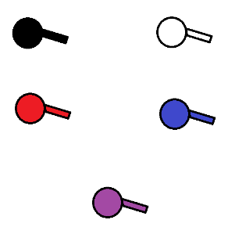

It was then decided to add some variety in shapes to the characters



This led to the full prototype sheet of characters that was inclusive of a variety of looks and colours

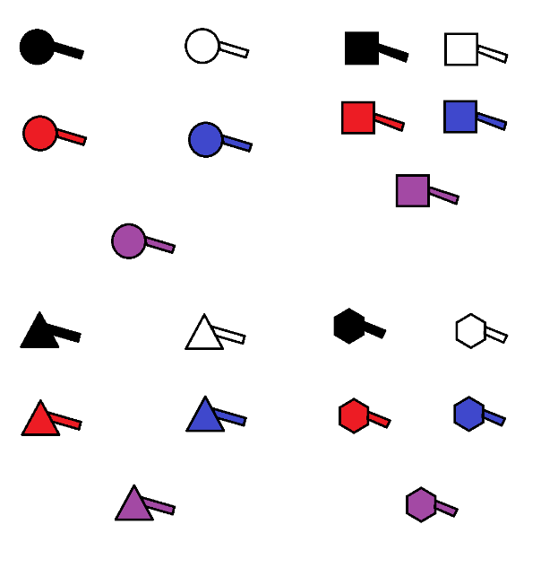

\*to be added to